Training Fiche Template

Title | Online communication, visibility and networking for cultural tourism businesses
Keywords (meta tag) | Networking, Branding, Web, Internet, Social Media, SEO, SEM, Online Positioning, Tourism, Enterprise
Provided by | Internet Web Solutions
Language | English
Area | Marketing and Branding
Objectives / goals / learning outcomes
The main goal of this course is to teach how to design and manage a website for an enterprise in the touristic sector and how to achieve a good online positioning and visibility. Bcv b
Description
This course offers a clear and succinct training about planning, management and improvement of your website on search engines and social media.
Contents arranged in 3 levels
- Online communication, visibility and networking for cultural tourism businesses
  - What to take into consideration when creating a website?
    - Why creating a website?
The main goal of a website is making itself known on the Internet and provide users with information about services and products that our business can offer. In the touristic sector is particularly relevant as it makes easier the contact between the enterprise and the customer (which is not always possible offline).
When creating an effective website for your business, there are many points to take into consideration. Decisions must be thoughtful and taking into account the features, purposes and customers of our enterprise.
Nowadays, if you are not on the Internet, YOU DO NOT EXIST. Therefore, it is necessary to develop our website so as many users as possible can access it, and making our business known.
    - Objectives
Set the main goals of your particular online strategy. The decisions made in the process of creating our website must pursue these goals. By stablishing these goals to follow, the development process is clearer, leaving aside arbitrary decisions that do not bring any benefit.
For example, if we manage an online shop, our goal will be the sale of products. Instead, a graphic designs company, will expose their works on their website and their purpose will be information and contact. In the touristic case, our website must be a combination of both goals.
    - Web Design
The design of our website is very important, because “a picture is worth a thousand words”.
You must take into account the public to whom our services are focused (age, educational level, language…). Therefore, our web design must be focused to our customers and not the other way.
A good logotype is essential as it gives our company an image that allows the customer to remember us more easily. This will also provide credibility and seriousness. The use of certain colours (corporate colours) will also allow to transmit specific sensations.
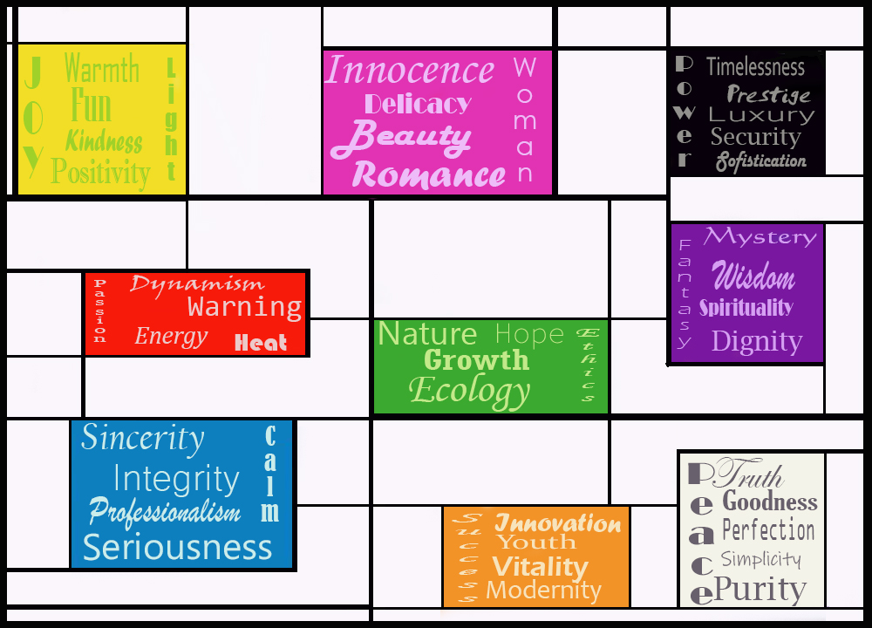

    - Make Online Navigation easier:
Our website must be easy to use, not to make it difficult for the user to access, as it can make them to search for other websites. Accessibility is completely essential; contents, sections and information must be clearly structured and visible. Otherwise, the user will look for alternatives in competence enterprises.
It is also positive to make information easier to read, by reducing it to brief paragraphs, with specific keyword that allows to spot the information that the users are interested in.
    - Adaptative Design: Responsive
The responsive design allows the correct visualisation of our website regardless of the device we access from (smartphones, tablets, computers…) by adapting our webpage.
The responsive design allows an extraordinary accessibility, as the website will continue offering all their possibilities regardless of the device used.
    - Information and reference
When creating a website, we can put ourselves on professional hands, or develop it on our own. Both of them are completely acceptable, but if we decide to develop our own website we must search and inform ourselves.
-Research successful websites you know: what is their web design like? How do they expose the information or products? Is it easy to navigate their platform? What does attract your attention?
-Use these models as a reference, but DO NOT PLAGIARIZE. Research their key to success and apply them the strategies and objectives to your business. Having references is not bad, imitating is.
-Innovate: Everything on the Internet is constantly changing. Thousands of websites are created and updated every minute. If you notice something is not working on your webpage, do not be afraid to change it
  - Online Positioning
    - What is Online Positioning?
Online Positioning is the process to improve a website visibility on the results of different browsers. Thus, an effective online positioning will allow the user to find our website easily when searching for websites with services like ours.
    - SEO (Search Engine Optimization)
It is a digital marketing technique that allows to improve our website visibility on search engines to increase traffic volume. It is also known as organic or natural positioning, or web positioning.
Being a type of online positioning, it allows our page to appear in the higher places when searching on browsers, and therefore, to achieve a greater number of visits on our website. But, how do we achieve that?
    - How does SEO work?
Let´s suppose a user is interested in finding a hotel in Madrid. If we do the search “Hotels in Madrid”, we will see that the pages positioned at the top are the ones that have more possibilities to attract the public.
This happens because users assume that the search engine offers the most relevant results first (as they have more possibilities of offering the desired product), so they will be the webs with more potentials views. There’s the importance of online positioning.
But how do I get my website to appear among the firsts results?
The search engine will position your website according to an algorithm that determines the quality of the content. This algorithm takes into account the following criteria:
-User experience (UX): the experience is valued as it is assumed that the higher it is, the higher the quality of the contents.
-Concordance: relative to the keywords and the website content.
-Authority: based on the experience of the company within its professional sector.
-Keywords repetition, density and dispersion.
-Frequent updates, as they show activity and adaptation.
There are many other factors that exceed 200 criteria; among the most relevant are browsing, loading time, absence of broken links or the presence of multimedia and/or interactive contents.
The SEO factors explained for Google (the most used Search Engine) can be consulted in the following link: https://www.aeuroweb.com/200-factores-seo/
All this criteria must be taken into account when creating our website and improving our online positioning.
    - What types of SEO there are?
There are two types of SEO:
-SEO On Page or On Site: includes the aspects that improve our website (modifications, programming, changes, links, loading speed...). Is specially important the HTML (the mainstay of our website) and the appropiate use of keywords.
SEO On Page also has two other types of SEO. The Copyright SEO looks for the appropiate structure and unique contents. To enhance our website, we must make a reasearch of the keywords, searching intentions, titles, and summaries.
The Technical SEO analyzes aspects that can be improved for users and search engines. They refer to programming and are not usually vissible for Internet users.
-SEO Off Page: Includes aspects that corncern the actions made off page, to achieve a higher number of views on our website. Among this type of SEO, registration in directories, linkbuilding, advertising on social media, banners.
The perfect SEO would be a combination to achieve the optimum online positioning.
    - SEM
SEM (Search Engine Marketing) consists in payment campaings on search engines that can modify online positioning. SEM is complementary to SEO (not alternative) and includes bids and advertising sponsored by browser. It is also known as PPC (Pay Per Click).
  - Marketing Online and Social Media Management
    - Marketing Online: Branding Fundamentals and digital comunication
Consists in strategies developement and practice to produce an enterprise or product brand. As we have said before, the online network is crucial to achieve success, therefore we must practice branding on our website.
Al Ries, a great exponent in the Marketing World, along with her daughter Laura Ries, list on their book “11 Immutable Laws of Branding on the Net”. They can be consulted in this link: https://www.foromarketing.com/el-branding-en-internet-nueva-necesidad-de-las-empresas/ but we have summarized them in this keypoints:
-The law of Either/Both: the network is either a new business or a new media, not both.
-The law of Interactivity: without this, website would fail.
-The law of Common Names: common names (with some exceptions) make poor brands.
-The law of the Proper Names: a generic name does not work as well as a short, unique, ponounceable, apealling, striking and original brand name, related with the activity.
-The law of Singularity: second brands do not work on the Internet.
-The law of Advertising: Offline advertising has to be a lot bigger than Online advertising.
-The law of Globalism: The Internet breaks all limits and barriers, so our website must be able to get to any place in the world.
-The law of Time: you must be fast. You must be the fist. Do not miss any opportunities .
-The law of Vanity: It defends specification against diversification. Do not include more and more categories under a single brand.
-The law of Divergence: “All-in-one” services do not success on the Internet.
-The law of Transformation: The Internet will transform a lot of aspects of our lives, and that includes marketing, companies and business.
Another aspect to take into account is the sesation our company causes, as it defines our customers opinion. Here’s some advice on brading online:
-Name: you must avoid generic names, and look for stricking, original, coherent, pronounceable, not too long names. A slogan can help with this task.
-Personality: look for something different, don’t follow trends. Try creating a look that allows to recognize our company’s style at first sight: a special typography, representative elements or the using corporate colors. But first of all, simplicity. On branding online, less is more. Simplicity makes understanding and retention a lot easier. In addition, interactive contents will bring interest and closeness.
-Essence: all the material (online and physical) must have the same essence. That’s why, from websites to business cards, must have the same corporative image. Otherwise, the user will not associate some aspects with others even if it is the same company.
-Clarity: Use a simple language when you talk with your customers. Do not use technical terms (unless we refer to a high specificity company), be clear and expose shortly and concisely the benefits of your services. A long text with technical terms will distance the company from the customer.
-Market Research Study: Essential phase of the process. Know your competence (what differentiates you from them?), and your customer (know their profile: age, nationalities, used platforms, level of studies...). All of this can help us develope an efficient online branding, and adapt our platform to the average user. Study their needs and how to help them satisfy them.
-Dialogue: Listen to the user. A comments system or feedback can be very useful, as you can receive critics and contributions, as well as opinions about your services to know how to improve them.
-Social Media: an useful tool to make your business known on the Internet. Millions of user can access to your services with a single click. In the following section we will talk about efficient social media management.
-Investigate and Innovate: have an open mind. Research for successful brands and their features, as well as designs and marketing campaigns. Get inspired by them to create new and functional contents, but do not plagiarize. Learn from mistakes and use them to improve, since failure is the key to success.
All this advice will help the user to “conect” better with yout online company in a easy and effective way.
    - Social Media Management
As we have seen in this course; the Internet is your friend when enhacing your business, and social media are essential tools to achieve that. Thus, is crucial to learn how to manage them effectively to get to our users. To do this, we must follow a series of guidelines:
-Define your strategy: As we have seen before, we need to define some objectives and define an strategy to get to them. Research for techniques, profiles and interests. Once we have done this, we can put it into practice.
-Find the right social media: Not all the social network have the same function, the same users nor the same management. Research and know those that allows you to get to the user more easy and effectively. Avoid creating an excessive number of profiles, “do not bite more than you can chew”.

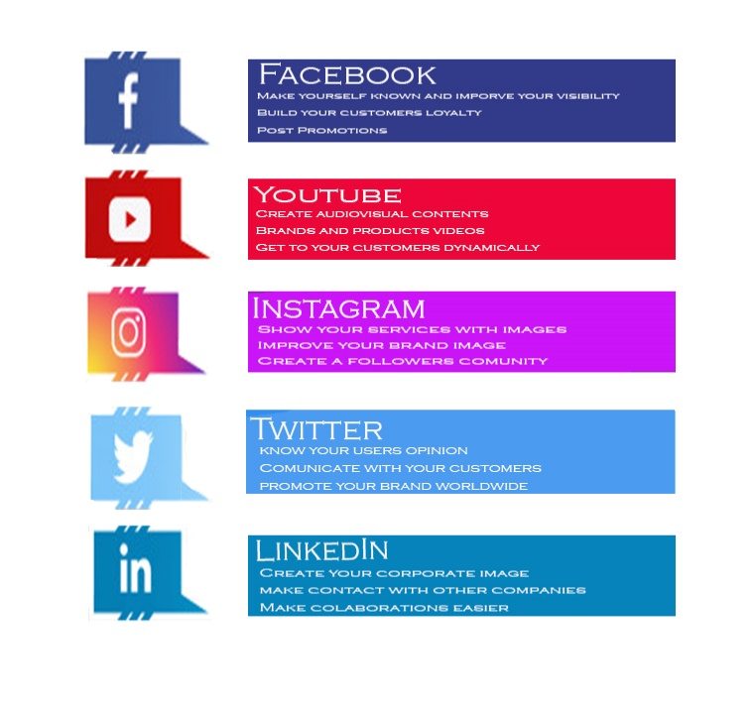

-Do not hurry: followers are important, but you should not obsess. A good marketing strategy will end up bringing users and followers to your website, but there is a long development and working behind it, constant innovation and updating to get to it.
-Update: publish new content frequently. Look for the perfect balance: a lot of publications a day can tire the user, and leaving the page for months will not keep his interest. Adjust the content and the frecuence of updates to the user’s profile and interests, as well as the network used.
-Organization: plan the contents, do not leave it to luck. Look after the presentation, the content and updates. An unorganized website will make an unprofessional impression.
-Analyze: Check account statistics. In most of them, these are easily accessible, so you must research the attracted profiles, how to enhance it or correct it. As we have said before, do not be afraid to change things and make them work.
-Adapt: If there are trends or contents that interest your users, do not be afraid to include them. This will help to make an impression on a comapy committed to today.
-Interaction: Make your users participate. Encourage them to comment, create interactive content, and listen to what they have to say. After all, they are user of our services, so their opinion is very important.

Conclusions
ICT tools could literally get your business off the ground. A right mix between a well-structured web design, a communicative logo and corporative image, a rooted communication on social networks will guide you in this new experience as entrepreneur.
However, always keep in mind that creativity and motivation are the main ingredients for your business recipes.

Socrative Questions (n.3)
- What’s “branding”?
- Creation and development of a brand.
- A type of SEO
- The website of an Enterprise.
- Which type of online positioning is more important on Search Engines?
- SEM (Search Online Marketing)
- Social Media
- SEO (Search Online Optimization)
- What must you do in order to correctly manage your website?
- Research for other websites
- Rarely upload contents.
- Ignore comments with negative opinions.
5 glossary entries
-RESPONSIVE DESIGN: Web design that allows to adapt the visualization to the device where we access from (tablet, smartphone, computer…)
-SEO: “Search Engine Optimization” acronym. Is a digital marketing technique that allows to improve our page visibility to increase the traffic volume. Also known as organic or natural positioning.
-SEM: “Search Engine Marketing” acronym. They are paying campaigns on search engines, that allow to change online positioning. Also known as PPC or “Pay Per Click”.
- SEARCH ENGINES: Informatic systems that search for files stored on web servers basing on keywords, thanks to the “web crawler”.
-BRANDING: Refers to the process of creating and developing a useful and solid brand.
Bibliography and Further References
https://www.entrepreneur.com/article/248347
https://www.nonplagiarismgenerator.com/
https://www.business.gov.au/Marketing/Online-presence/Social-media-for-business
https://innovationmanagement.se/2017/12/08/innovative-web-design-elements-that-will-improve-your-business-website/
https://www.agency97.com/blog/8-creative-and-innovative-ways-to-inform-and-improve-your-websites-content/
https://www.boardofinnovation.com/blog/100-sources-that-every-innovation-professional-should-know-about/
https://www.wordstream.com/search-engine-marketin
https://windup.es/pack-promocion-marketing-digital/?gclid=CjwKCAjwlID8BRAFEiwAnUoK1eW7AcPg-P2kd46zoUrZX8DcaIZQwoPMkkQrmsHlRUlWtF1A0R3cIBoCeikQAvD_BwE
https://www.designhill.com/design-blog/unique-branding-ideas/
https://freshsparks.com/business-branding/

Related Material | All_Routes_Lead_To_Rome_Trainig_Comunication_Online_EN.doc
Related PPT | All_Routes_Lead_To_Rome_Trainig_Comunication_Online_EN.ppt
Reference Link

